Grade : 12 PERIODIC TEST – 1 Date : 13.06.22

Marks: 20 ENGLISH CORE Time : 40min

I.Read the passage given below:

Consumers seeking entertainment and social interaction are increasingly turning to video games. video gaming has increased both in popularity and time spent playing. Socialising around game play is important. Over the past year many started playing the games and watching others playing also.
With the rise of social media, gamers – particularly in Gen Z – have perfected the art of building communities in and around video games. Gamers don’t just compete with strangers on the internet, but forge genuine, enduring friendships.
In this age of long-haul social distancing and mental-health strains, gamers have long had a tool that’s now bringing some relief to those who’ve never picked up a controller before. The explosive growth of gaming during the pandemic has shown that many have found a new outlet for much-needed connection in isolation.
Mark Griffiths is a professor at Nottingham Trent University who’s written about gaming friendships in the pandemic, and studied socialization in video games for decades. In 2003, he published a study that showed a quarter of 11,000 players of the online role- playing game .Their favorite part of the game was connecting with other players. He says the study was a direct and early contradiction of the stereotype that video games are isolating. In another study from 2007, he looked at 912 players of massively multiplayer online (MMO) role-playing games from 45 countries who played on average around 22 hours a week, concluding that the online game environment was “highly socially interactive”. Lopez says that games have helped old and new players alike “keep connected, social and sane” during the pandemic. “For a long time, people have either looked down on that or called gamers ‘weird’, but now people and companies want to know how to maintain relationships and communities digitally. It's more accessible for people.”
So, although more people staring at a screen may seem like an unhealthy habit, even the World Health Organization believes it could be key in nurturing our bonds with others.
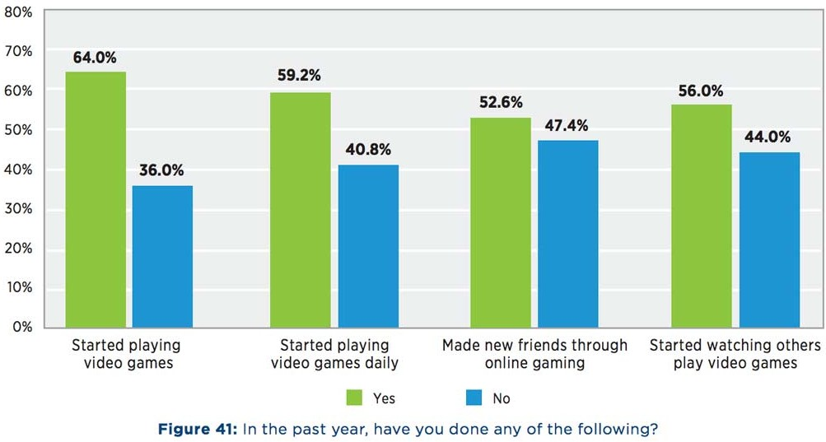
A sample percentage of playing video games and making friends is displayed

Based on your understanding of the passage, answer all questions given below.(1x8=8m)

1.Why have people shifted to online games in the past year?
2.There has been a sudden explosion of games during the pandemic. State the reason.
3. Mark Griffith’s study revealed a contrast. What was it? Pick out the line from the passage that justifies it.
4.What does the researcher mean by “highly socially interactive”?
5.The researcher says,” It's more accessible for people.” Comment on his view.

6. What can be concluded on the opinion of WHO on online gaming?
7. Based on the figure, draw one conclusion about online gaming.
8. Give the meaning of long-haul.
II. You lost your Titan wrist-watch in your school. Draft a notice, in not more than 50 words, to be placed on your school notice board. You are a student of Class XII of Rani Ahalya Devi Senior Secondary School, Gwalior. Sign as Rani/Ram. (4m)
III. Answer the following questions accordingly:
(a) Why did M.Hamel say: “We’ve all a great deal to reproach ourselves with?” (20 -30words) (2marks)
(b) Define Linguistic Chauvinism. Compare and contrast Germany’s imposition of German language and the sudden arousal of love for French in the people of Alsace. (100-120 words) (6m)

